Title: Critical Decision-Making Model
Recommended Time: 2 hours
Primary Audience: Patrol Officers
Module Goal: Through classroom instruction and discussion, introduce and explain the Critical Decision-Making Model (CDM) for use by patrol officers in managing critical incidents, especially those involving subjects who not armed with firearms and who may be experiencing a mental health or other crisis.
Required Materials: Digital presentation (Power Point, videos); lesson plan
Learning Objectives: At the completion of this course, students will be able to:
  - Describe the key principles of the Critical Decision-Making Model (CDM).
  - Explain each of the five steps of the CDM.
  - Explain the principles of threat assessment, including dynamic risk.
  - Understand and articulate the benefits of the CDM.
  - Use the CDM to describe the actions of a police officer handling a critical incident, through a video case study.

Recommended Time Allocation
 | Unit | Recommended Time  (minutes)
1 | CDM Overview | 10
2 | CDM Core | 5
3 | CDM Steps | 40
3a | Step 1: Collect Information
3b | Step 2: Assess Situation, Threats and Risks
3c | Step 3: Consider Police Powers and Agency Policy
3d | Step 4: Identify Options and Determine Best Course of Action
3e | Step 5: Act, review and Re-assess
4 | CDM Uses and Benefits | 5
5 | Video Case Study: CDM in Action | 25
6 | Learning Activity–1 (CDM Review) | 30
7 | Recap and Discussion | 5
Total |  | 120

Table of Contents

- CDM Overview 4
- CDM Core 5
- CDM Steps 5
  - Step 1: Collect Information 5
  - Step 2: Assess situation, threat and risks 8
  - Step 3: Consider police powers and agency policy 10
  - Step 4: Identify options, determine best course of action 10
  - Step 5: Act, review and re-assess 12
- CDM Uses and Benefits 13
- Video Case Study: The CDM in Action 15
- Learning Activity--1 (CDM Review) 18
- Recap and Discussion 18
Appendix I -- Background on PERF's Critical Decision-Making Model 19
Appendix II -- Some Common Offender Risk Behaviors 25

- CDM Overview

Recommendation

One effective way to open this Module is for the instructor to engage the class in a guided discussion that “builds” the model from scratch on a chalk- or white-board. Start by asking the class, “What guides all of our actions?” Answer: values, ethics, mission. Write that in the center on the board (core). Then ask, “What’s the first thing you do when you get an assignment?” Answer: collect information (Step #1). Next ask, “Once you get on scene, what do you do?” Answer: assess the situation, threats and risks (Step #2). Continue the discussion for Steps #3, #4 and #5, writing each answer in a circle around the model core. Conclude by showing Slide #2 and pointing out that the students have, in essence, created the CDM. This approach introduces the CDM in a non-threatening manner and demonstrates that most officers already use it naturally, without slowing down or stopping to check a box.

  - Introduce CDM
    - It describes a process police officers follow every day
      - Puts a name and a flow to that process
      - Presents a way to understand and structure your decision-making … without interfering with your ability to act or jeopardizing officer safety
    - Why is this valuable? Two reasons:
      - Helps you make better decisions up front – a reminder to not skip crucial steps in decision-making and to continually re-evaluate the situation
      - Helps you explain your decision later on – to supervisors, investigators, in court
    - Typical reaction at first:
      - Too complicated
      - Will slow me down, won’t be able to act if I need to
      - Officers will get hurt
      - Just another “checklist” that officers must follow
    - We’ll address those issues as we go through
      - Keep an open mind
      - Think about how you make decisions
- CDM is a foundation of the entire ICAT approach
Instructor Notes

SLIDE #1
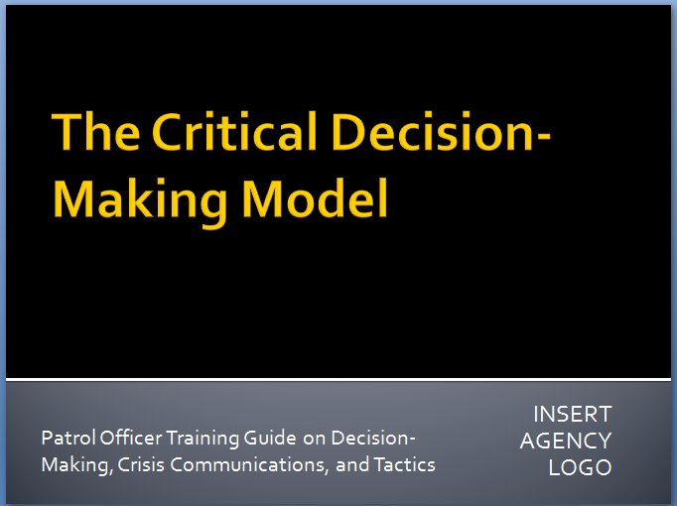

For background on the CDM, see Appendix I, p.19. Also available at http://www.policeforum.org/assets/guidingprinciples1.pdf (pp. 79-87)

SLIDE #2
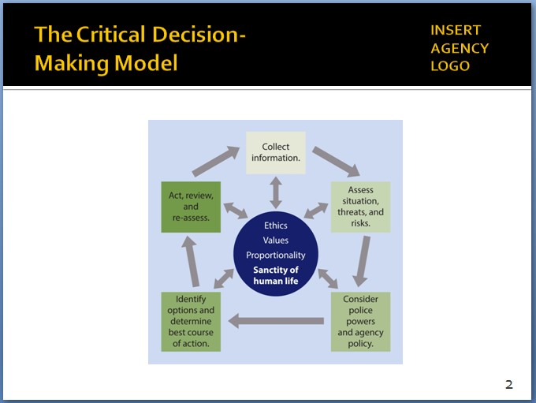

The CDM is similar to the OODA Loop (Observe, Orient, Decide, Act) used by the military and some police agencies.

Concerns about and benefits of the CDM are covered in more detail later in this module (Slides 18-20).

If students ask, the CDM is based on the National Decision Model pioneered in the United Kingdom, where it is taught to all police recruits and used in a range of situations. The CDM has been tweaked to better fit with American policing. For background on UK’s NDM, see: https://www.app.college.police.uk/app-content/national-decision-model/

Some U.S. agencies have begun adopting the CDM and teaching it to their recruit and veteran officers. For background on use of the model in Nassau County, NY see http://www.policeforum.org/assets/guidingprinciples1.pdf (pp. 83-84)

- CDM Core
Instructor Notes

SLIDE #3
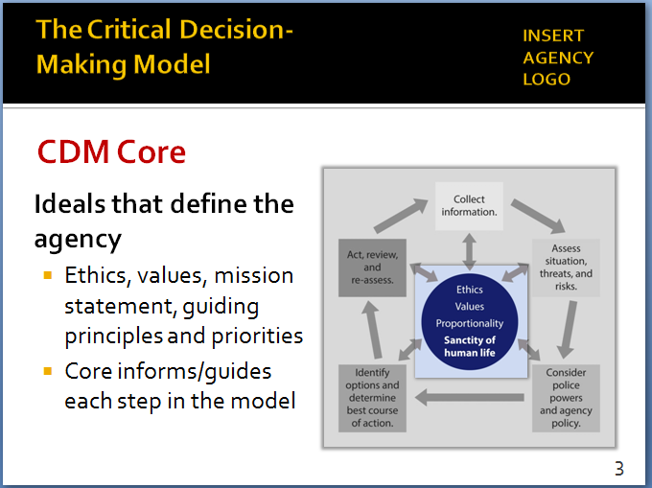

This slide reflects the CDM as recommended by PERF. Like Nassau County, agencies should adjust/ customize the model and its core to reflect their mission, values and priorities.

Here is what Nassau County’s decision model looks like:

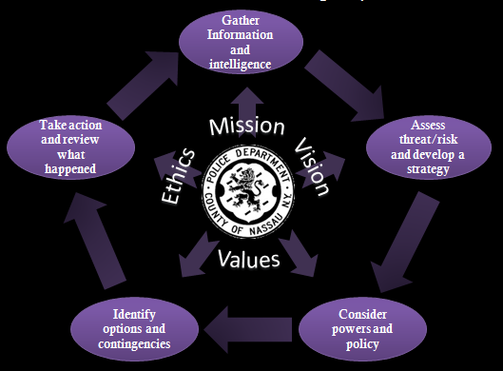

“Spinning the model” concept is covered in greater detail on Slide 17, p. 12.

SLIDE #4
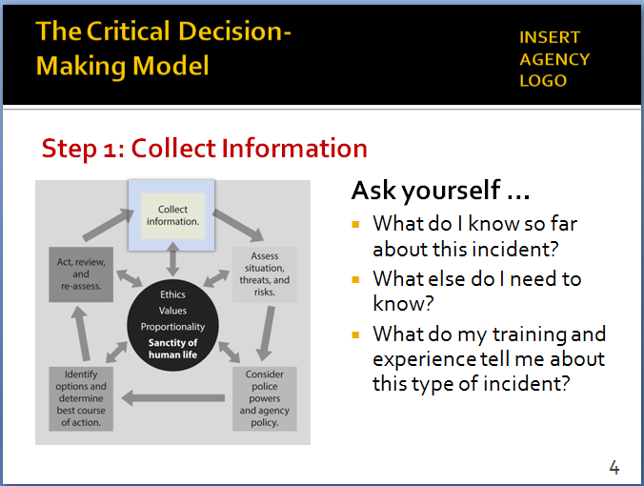

Separating facts from assumptions can make all the difference in effective decision-making. Information gathering in the CDM is a way to turn assumptions into facts.
  - CDM starts with its core
    - Your agency’s “moral compass”
    - Reflects key principles/priorities
  - Core is unique to each agency
    - Reflects agency mission, values, vision and ethics
    - CDM is a values-based tool -- the core needs to reflect those values
  - Arrows run both directions between core and five steps
    - Core informs/guides each step – ensures officers’ actions are based on agency mission and values
    - No step can contradict ethics/values in the core
- CDM Steps 1-5
  - A 5-step model:
    - Circular … not linear … process
    - Supports constant re-assessment of situations, threats and risks (based on new information) and re-calibrating of decision-making
    - A process known as “spinning the model”
IIIa. Step 1: Collect Information
- First step in the model …
- But gathering information doesn’t stop here – it is an ongoing process
- From the time an officer gets a call all the way through report writing/debrief (i.e., lessons learned that can be applied the next time)
- Continual process of trying to turn assumptions into facts – you can act on assumptions, but always better/safer to act on facts

- Ask yourself three key questions
Instructor Notes

SLIDE #5
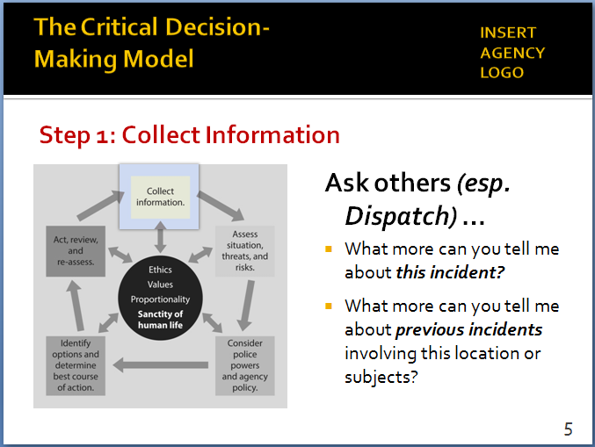

In cases involving persons with mental illness, it is especially important for responding officers to get answers to such questions as:
- Does the person have a mental health condition?
- Is he/she taking medication?
- Does he/she have a doctor or therapist?
The caller, family members, or others on the scene can often provide this information.

SLIDE #6
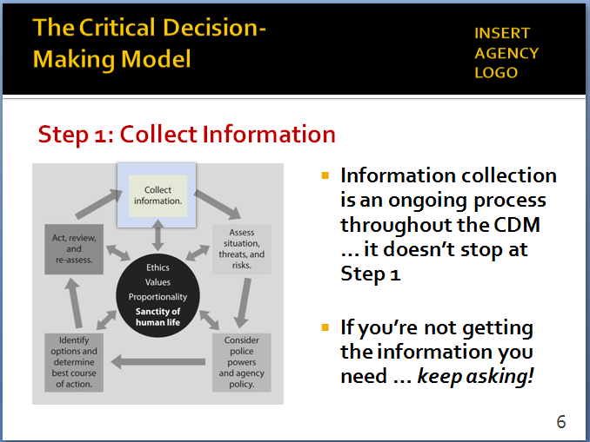

- What do I know about subject, victim, and location?
- What further information do I want or need to know?
- What do my training and experience tell me about this type of incident (lessons learned from past calls)?
- Ask others for information (Dispatch, supervisors, other officers, agency computer networks, family members, others on the scene)
- Ask about this incident
      - Who called – and what prompted the call?
      - What do we know about the subject?
      - What is the physical environment?
      - Are there weapons, children or animals on scene?
      - Are there mental health or substance abuse issues?
- Ask about previous incidents involving this location/ individuals
- Past arrests?
- Violent behavior, including assaults on officers?
- Past uses of force?
- Gathering information/intelligence is an ongoing process
- If you’re not getting information you need … keep asking/probing
- Information collection is the foundation for CDM Steps 2-5
- Information collection also continues throughout Steps 2-5
  - You should never be satisfied with the information you have at the moment
  - The CDM prompts you to always be thinking about collecting more information

Reminders
Instructor Notes

SLIDE #7
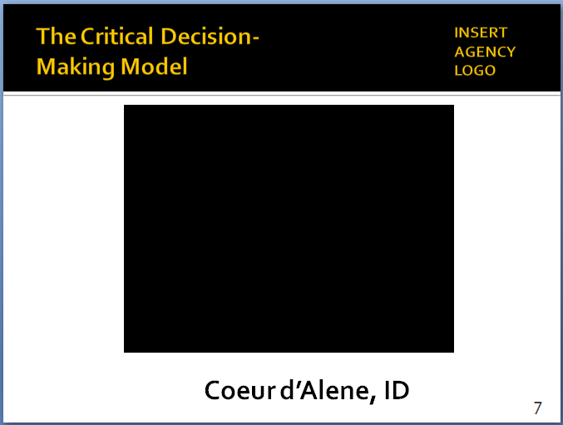
Also available at https://www.youtube.com/watch?v=_FcrJDhelug

Subsequent news article revealed the woman on the porch had been in the vehicle with subject when it crashed; it was her house; subject was concerned about going back to jail for DUI; had long history of substance abuse and traffic violations; had displayed knife in non-threatening manner; was generally soft-spoken and reserved. http://www.spokesman.com/stories/2013/aug/26/man-shot-killed-cda-police-identified/

Also, http://cdapress.com/news/local_news/article_e66c8196-7e68-11e3-a97e-001a4bcf887a.html

Two reminders prior to showing this and other videos:
- Set up the video; provide some background information and context.
- Remind students that the videos are not meant to be “good” and “bad” examples; the purpose is not to judge or second-guess the officers’ actions or render a grade. Rather the videos illustrate the real-world challenges officers face. The purpose is to generate discussion on how these challenges might be handled as safely and effectively as possible.

- Video Case Study: Information collection
    - Coeur d’Alene, Idaho – August 25, 2013, 0800 hours
    - Police respond to report of a pickup truck striking a utility police – trace the driver to the nearby home of a friend
    - Begin video – STOP at 1:35 mark and discuss
  - What information did officer get from the woman? (Has a knife and might want to harm himself.)
  - Did he get enough information? What more information might have helped? (Anybody else in the home? Other weapons? Subject’s history and mental state?)
- Did he have enough time to ask more questions, get more information? Or did he need to go right in? (Came back out to ask more questions.)
- Any officer safety issues?
    - Resume video – play until end and discuss
- Had the officer taken time to collect more information, how might he have approached the situation differently? Who forced the action?
- Might the outcome have been different?
    - Video illustrates that information collection is critical
- Any questions about Step 1 in the CDM?

IIIb. Step 2: Assess Situation, Threat and Risks
- Four key questions to ask yourself at this step:
- Do I need to take immediate action?
- Nothing in the CDM prevents you from taking immediate action if circumstances dictate
- Including use of lethal or less-lethal force
- If I don’t need to act immediately, what more information do I need?
  - About the subject (intent and capability)
  - About the location/environment
  - About any victims
- Am I trained and equipped to handle this situation myself? Or do I need other resources – supervisor, specialized units, K9, other agencies?
- What is the threat or risk?
- Threat assessment means accurately evaluating any person, object or environmental factor that could put the public or an officer at risk
Instructor Notes
SLIDE #8
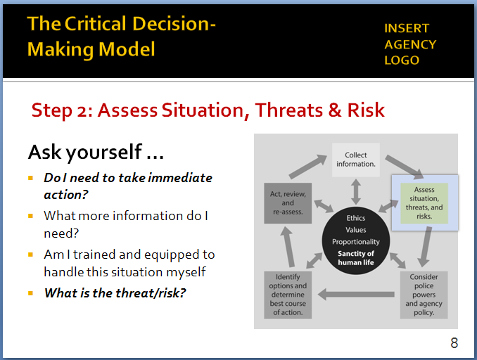

A common complaint with this type of model is that officers will hesitate or be reluctant to take action when needed. Emphasize that is not the case with the CDM.

SLIDE #9
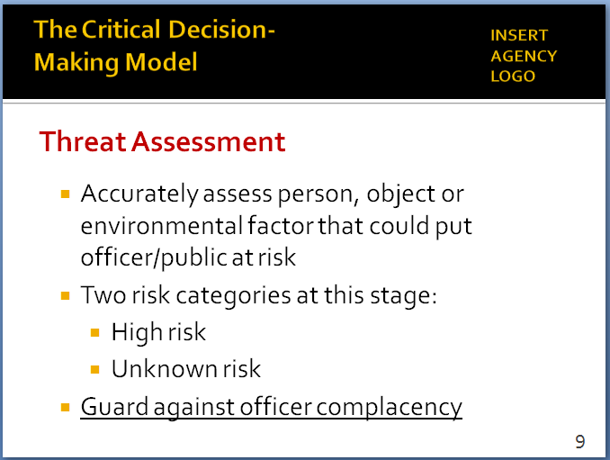

See Appendix II for more details on common offender risk behaviors.

- At this stage, there is really only …
  - High risk (which may require immediate action)
  - Unknown risk
  - Don’t assume that because the situation is not “high risk” that it is automatically “low risk”
    - You probably don’t have enough information to make an accurate assessment at this point
    - If risk is “unknown” … keep collecting information
- Guard against complacency while you’re assessing the threat and risks
  - Big officer safety issue
  - It’s hard to be complacent when you’re going through the CDM – it helps to keep you focused

- In this step you begin to assess the subject’s:
Instructor Notes
SLIDE #10
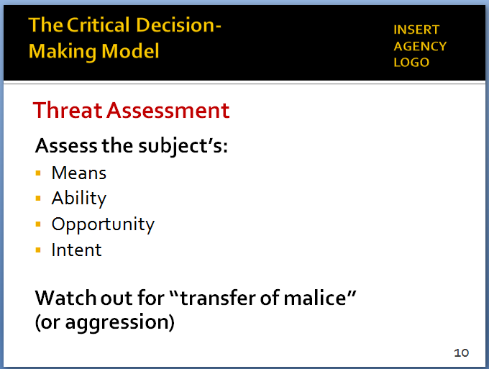

This can be a difficult concept for some officers to embrace: that the exact same weapon in different hands and circumstances might pose different threats.

In the St. Louis video, what was the subject doing with the knife? Was it an imminent threat? Or a potential threat?

SLIDE #11
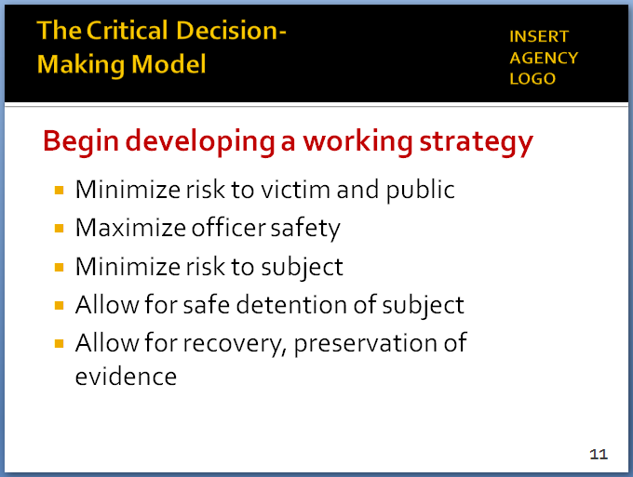

.

SLIDE #12
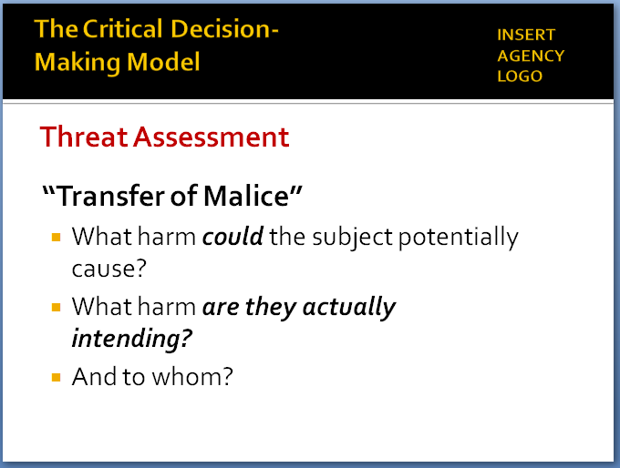

  - Means
  - Ability
  - Opportunity
  - Intent
  - Remember: these can change as situation unfolds
- For example, it’s important to look beyond the mere presence of a weapon (knife, bat, other impact weapon)
  - What is subject doing with the weapon (intent)?
  - Potential threat vs. imminent threat
  - Intent to do harm (offensive action) vs. self-protection (defensive action)
  - Understanding these differences will influence your decision-making and response
- Another factor in threat assessment – “transfer of malice” (or aggression)
- Subject may be initially upset with spouse, boss, etc.
- Is he showing signs of transferring those emotions to the police or others?
- Try to contain that aggression – and avoid doing anything that causes the subject to transfer his/her aggression to you or others
- Step 2 is also where you begin to develop a working strategy. What can I do to …
- Minimize risk to the victim
- Minimize risk to public and immediate area
- Maximize safety of officer
- Minimize risk to subject
- Allow for safe detention and arrest of subject
- Allow for recovery and preservation of evidence
- Any questions about Step 2?
IIIc. Step 3: Consider Police Powers and Agency Policy
Instructor Notes

SLIDE #12
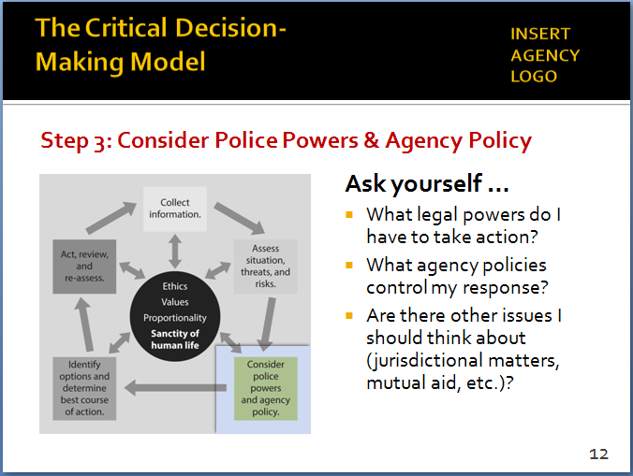

When a SWAT team is requested and arrives at a scene, the first thing the SWAT commander typically asks is, “What is the crime we are here for?” Patrol officers should adopt a similar mindset.

Officers responding to assist in a neighboring jurisdiction always need to understand and consider the policies and approaches of that jurisdiction and follow the lead of the primary agency. Similarly, agencies must ensure that officers responding to assist them understand and follow your policies and approaches.

SLIDE #13
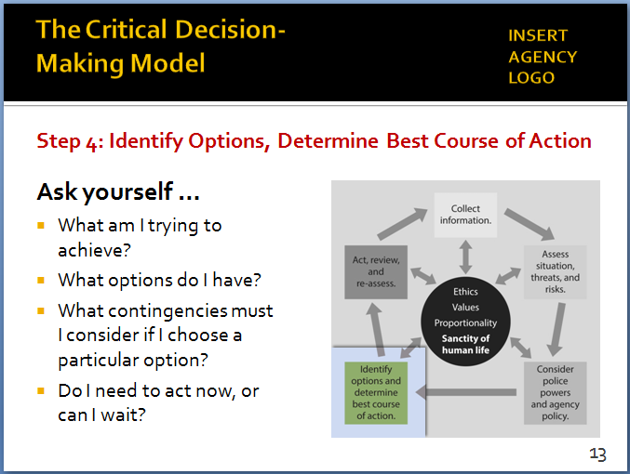

- A quick, but critically important, step in the model
- Before you finalize your strategy and take action, first ask yourself …
  - Under what legal authority am I here? Is this even a matter for the police?
  - What legal powers do I have to take action? What are the applicable …
    - Federal laws
    - State laws
    - Local ordinances
  - What agency policies control my response?
        - Use-of-force (e.g., shooting at vehicles)
        - Less-lethal (e.g., use of Taser/ECW)
        - Policy on de-escalation
  - Are there other issues to consider?
        - Jurisdictional issues
        - Mutual-aid
- Any questions about Step 3?
IIId. Step 4: Identify Options, Determine Best Course of Action
- From the “working strategy” developed in Step 2, this is where you narrow your options … then select the most appropriate and effective one
- Ask yourself …
      - What exactly am I trying to achieve? (Voluntary compliance? Protection of public? All of the above?)
      - What are my priorities? And my options?
      - What are the contingencies if I choose an option?
      - Do I have to act now or can I wait?
      - Do I have all the information I need to act now?

- Some notes about identifying options:
  - It is impossible (and unwise) to identify every option available to deal with the conflict – this step is about considering and narrowing best available options
Instructor Notes

SLIDE #14
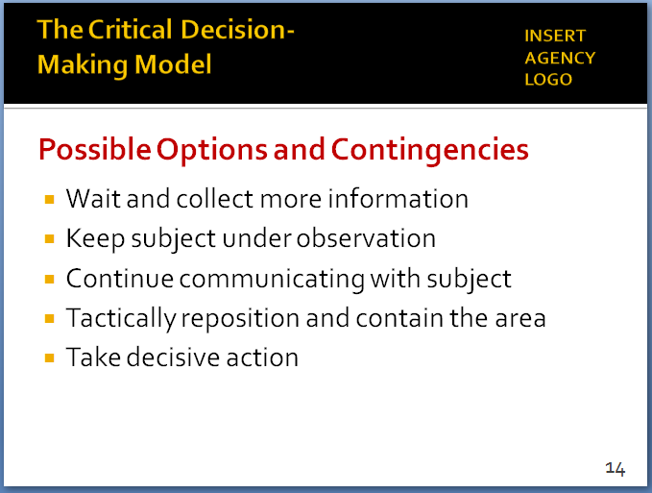

SLIDE #15
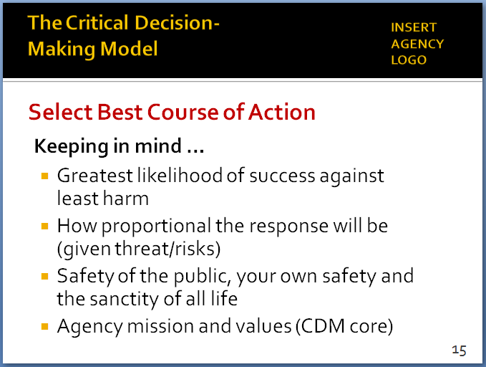
Although courts have recently begun to cite “proportionality” in some use-of-force rulings (see, for example, Armstrong v. Village of Pinehurst, http://www.ca4.uscourts.gov/Opinions/Published/151191.P.pdf), it is still a new concept for many police officers. For ICAT, proportionality involves a three-part test:
- Am I using the level of force necessary to mitigate the threat and safely achieve a lawful objective?
- Is there another, less injurious option available that will allow me to safely achieve the same objective?
- Will my actions be viewed as appropriate—by my agency and the public—given the severity of the threat and the totality of the circumstance?
For more background, see https://policeforum.org/assets/guidingprinciples1.pdf, pp. 38-40.
  - Just because you’ve created options doesn’t mean you need to act now – in some situations, waiting and collecting more information may be the best option
  - Continuing to communicate with the subject will almost always be an option
  - Tactical repositioning and containment may be an option in many cases
  - Or, taking decisive action may be required
    - Again, nothing in the CDM prevents you from taking swift and forceful action, if warranted
    - If you have time, CDM helps you use it effectively
- After considering options, then select the best course of action, keeping in mind …
  - Greatest likelihood of success against least harm
  - How proportional the response will be, given the risk/threats and totality of circumstances
    - Is the level of force used on a person commensurate with the danger he/she posed?
    - An option that carries a high risk of serious injury is less likely to be considered proportional when the threat posed only a limited risk to you and others
    - “Why use a sledgehammer to crack a nut?” (Sgt. Jim Young, Police Scotland)
  - The sanctity of human life – the public, the subject, your partners, your own safety
  - Agency mission and values (core of the CDM)
- Any questions about Step 4?
IIIe. Step 5: Act, Review and Re-assess
Instructor Notes

SLIDE #16
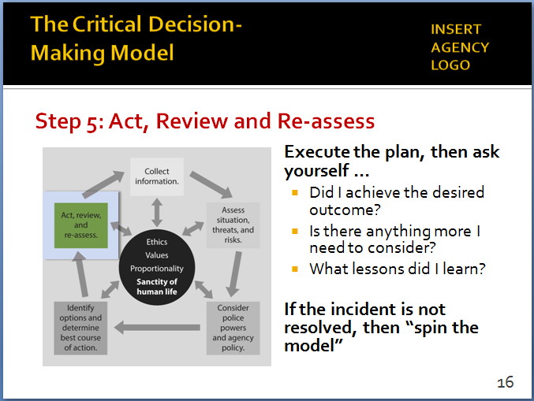

SLIDE #17
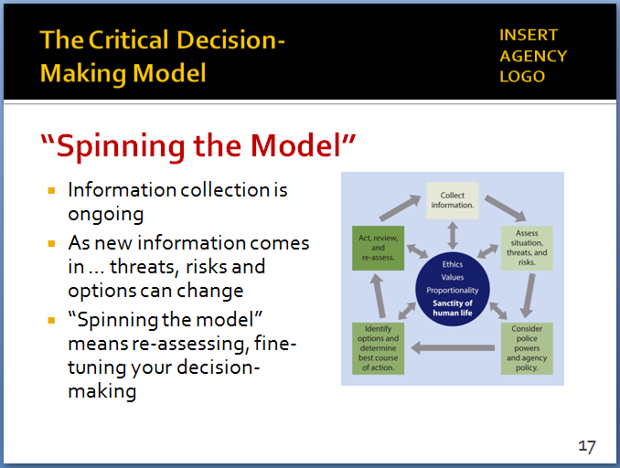

Communication and especially active listening are covered in Module 4.

We’ll see an example of how quickly the model can be spun in the next Video Case Study (p. 15).

- Final step: Take action
- Then, ask yourself …
  - Did I achieve what I set out to do?
  - Is there anything more I need to consider or do?
  - What lessons did I learn? How will this help me the next time I face a similar situation?
- If the situation isn’t resolved, then “spin the model” again
  - Circular structure of the CDM supports this continuous process of re-evaluation
  - Don’t forget – information collection is ongoing
        - Need to constantly seek out new information – trying to turn assumptions into facts
        - Always be alert to new information and intelligence
        - In many cases, what the subject tells you will be your best source of information and intelligence – that’s why communication and active listening are so important
  - As new information comes in, the threats, risks and options will likely change
  - “Spinning the model” can occur at any point in the process – whenever new information comes in
  - The model can be spun as quickly or as deliberately as appropriate – if you need to act right away, then spin the model at light speed
  - CDM provides a structure – a process – for supporting and fine-tuning your decision-making
- Any questions about Step 5?

- CDM Uses and Benefits
Instructor Notes

SLIDE #18
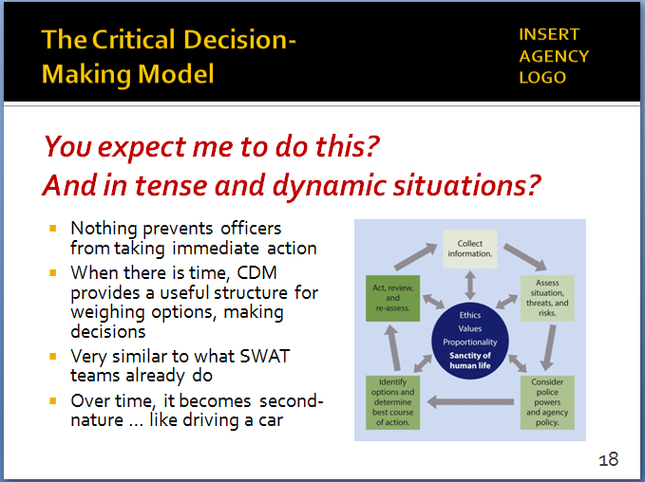

The basic principles behind the CDM are quite similar to the processes that have been used by SWAT and other specialized units for years. The CDM attempts to bring that same decision-making perspective and discipline to patrol officers.

See essay by Inspector Ronald Walsh, Nassau County (NY) Police Department: http://www.policeforum.org/assets/guidingprinciples1.pdf (pp. 83-84).

Use of this video is optional. If you think it will help students appreciate that the CDM can be taught and used in an agency, then show it. If that does not appear to be an issue, then this video can be skipped.

SLIDE #19
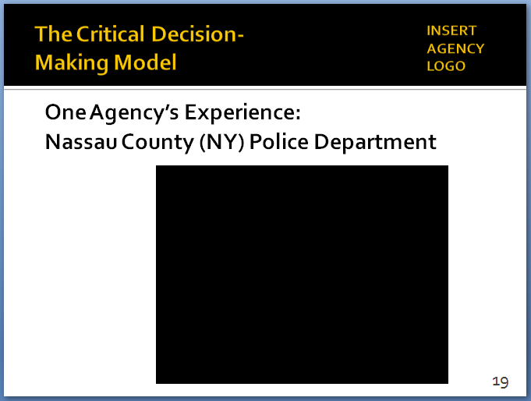

Video available at https://www.youtube.com/watch?v=5NCYvsEBAPU

  - Some of you are undoubtedly thinking, “How does this benefit me?”
    - At first glance, process may seem cumbersome
    - But a few things to remember
- Nothing in the CDM prevents you from taking action when you need to – at any step in the process
- CDM reflects what many of you already do every day – intuitively … usually without stopping to consciously “think”
- CDM also aligns with the thinking and processes used by SWAT and other specialized units
- CDM provides a structure and process to organize the decision-making process
- By always being alert for new information, CDM helps you make better decisions – split-second or otherwise
- Over time, “spinning the model” becomes second-nature … much like driving a car
- Optional Video Case Study: One agency’s experience with the CDM …
- Set up the video:
- Nassau County, NY adopted a CDM-like model a few years ago – teach it to all new recruits
- Asked some officers to discuss their thoughts and experiences
- Most of the officers had prior law enforcement experience
- Play Nassau County video
- Discuss briefly, as appropriate

- Benefits of the CDM
Instructor Notes

SLIDE #20
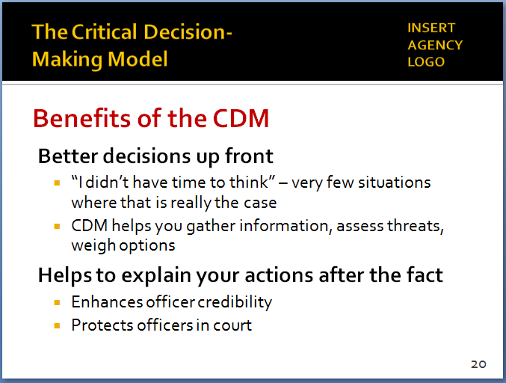

Police in the United Kingdom report that use of their National Decision Model to walk through and explain officer actions after the fact is one of the model’s most powerful benefits. It has dramatically enhanced officers’ credibility in court, and helped to stave off attacks from defense attorneys over officers’ decisions and actions.

- Supports you in making better decisions up front
        - Very few situations where you “don’t have time to think”
        - CDM provides a structure to collect information, assess threats and risks, weigh options and (ultimately) make better decisions
        - Helps you avoid skipping steps and rushing to judgment (often based on faulty /incomplete information or assumptions)
- CDM also helps you explain your actions after the fact
- A template for walking through your decision-making
i. “First, I collected the following information ….”
ii. “Next, I assessed the threats and risks, and developed a working strategy ….”
iii. “Then, I considered applicable laws and agency policies….”
        - This type of structured explanation can enhance officer credibility – with supervisors, investigators, juries, and the community
- CDM complements/supports everything else in this training – crisis recognition, communications, tactics
  - Provides the foundation and framework for everything we are talking about
  - You’ll need to be thinking about – and referring to – the CDM as we go through the other ICAT modules

- Video Case Study: CDM in Action
Instructor Notes

SLIDE #21
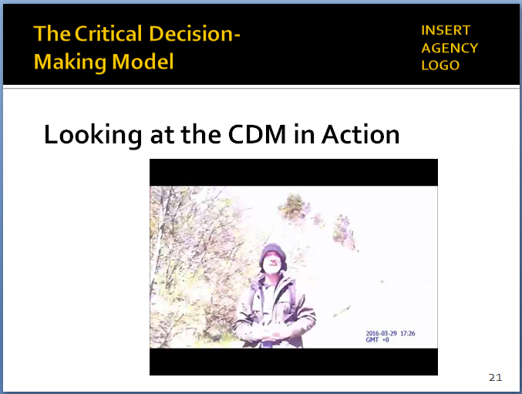

Video available at https://www.youtube.com/watch?v=VBY7zzsQVnU

For a description of the incident in the officer’s words, see https://www.themarshallproject.org/2016/06/16/i-m-a-cop-who-went-viral-for-not-killing-a-man#.cquZ7EbvU

When he was shown the CDM months after this incident, Officer Hilling remarked how accurately the model captured his decision-making process that day and how it could help other officers facing critical incidents.

Officer Hilling:
“But after starting to give me a name, he stopped, and then started giving a different name. I asked if he had any ID on him; he said no. I asked him if he had a Social Security number; he said no. At this point, I just felt something was a little off. I feel uncomfortable when I don't have something in my hand that tells me who somebody is.”
“I got on our county radio to inform all of the surrounding agencies where I was and what I was doing. That’s when the gentleman stuck his hands in his pockets, and I asked him to remove them. He did, voluntarily, with no problem.”

Note

This exercise is to illustrate how one officer used the principles of the CDM to manage a dynamic, dangerous encounter. During this case study, try to keep the focus on how the officer collected information, assessed risks/threats, weighed options, and decided what actions to take as conditions changed (i.e., how he “spun the model”).

A few reminders:
- Set up the video ahead of time; provide background and context.
- Remind students that the video is not meant to be a “good” or “bad” video; the purpose is not to judge or second-guess the officer’s actions or render a grade. Rather the video illustrates the real-world challenges officers face. The purpose is to generate discussion on how these challenges can be handled as safely and effectively as possible. We are not suggesting this was the only possible course of action in this case.
- With this video in particular, students will likely have issues with specific tactics employed by the officer. Again, try to keep the focus on his decision-making and not get side-tracked by too many ancillary issues (e.g., squad car door left open).
- The Instructor Notes include quotes from the officer explaining his thought process and why he did what he did. Use the officer’s words as much as possible to make your points about his decision-making.

  - Set up the video
    - Glendale, OH (small town outside Cincinnati)
    - March 29, 2016 – mid-day
    - Officer Josh Hilling – 3 months on the job full-time (had been a part-time officer for a few years)
    - Encounters a man walking along I-75
  - Start the video
    - Stop at 1:38
- What information has officer collected?
(Suspicious person, evasive in answering questions, no ID)
- What are the threats/risks?
(Unknown risks – complied with handing over backpack, taking hands out of pockets)
    - Restart -- stop at 2:00
Instructor Notes

Officer Hilling:
“There were two moments … that I will never forget. The first is when I put it together that he had a knife, and he was going to try to harm me. My adrenaline went through the roof; I'd be lying to you if I didn't tell you I was scared for my life. The second moment is right after I pulled that trigger. There was something that came over me that made me stop and think, instead of just reacting. What do I do next? The first thing that popped into my head was: Create distance between you and this person — who is trying to hurt you — and get help.
“He’s shot, so he’s not moving that well. He’s slow now. He’s not moving like he was before. So I figured, ‘OK, I can move faster than him now, I know that.’ And I have distance. That distance creates time. So if I make a decision that I want to pull back or do something else, I’ve got a little bit of time to recover. And he’s not at full strength anymore.”

Officer Hilling:
“As I was backing up, I was watching the highway, and a car stopped in the first lane, so I knew I was safe in that lane. And then other officers started showing up, so I had the whole highway.
“At first, as I was backing up, I didn’t want to fire again because I had all my backup and all those civilians in those cars downrange. So I repositioned myself and turned my body, so I’m facing southbound. Now I have nobody downrange except on the northbound lanes of the Interstate, which wound up being shut down as well.”
- What new information does the officer have?
(Has a knife, first indication of possible suicide-by-cop)
- How did the threat/risk change?
(Knife at close quarters, pushed away and shot, wounded, still has knife, has some distance, traffic)
- Officer was compelled to act immediately – and he did
- After acting, incident wasn’t resolved … so he “spun the model” with the new information – creating distance gave him time to do this
    - Restart -- stop at 3:20
- New information?
(Traffic stopped, backup arrived, non-compliant, suicide-by-cop)
- How has the threat/risk changed?
(Subject wounded but mobile, moving toward other officers)
- What are his options? Any compelling reason to act yet?
(Officer is constantly assessing and re-assessing)

    - Restart -- stop at 4:40
- New information?
(Continues walking, now toward civilian cars, more adamant about suicide-by-cop)
- Change in threat/risk?
(Civilians now at risk)
- Options? Any compelling reason to act yet?
(Maybe, but officer still felt he was in control)
    - Restart -- stop at 5:30
- Any new information?
(Losing stamina, stopping and staggering)
- Change in threat/risk
(Still has knife, unlikely to be able to use it)
- Officer acted (fired Taser), assessed, took into custody
    - Post-script
- Man (Javier Pable Aleman, age 46) was wanted for murder in Baltimore County, MD – had stabbed to death his former landlord
- Officer Hilling is back on the job – says the incident will affect him forever
    - Questions or comments?

Instructor Notes

Officer Hilling:
“Backup was arriving, we got him in an area, but at one point, you hear me say, ‘Shoot him,’ because I felt we were getting too close to civilians.
“He repeatedly told me to kill him. ‘Kill me, kill me, kill me.’ Someone told me he said it 40 times. But what he was telling me to do had no impact on me. I wasn’t worried about what he wanted. I’m the police officer. This is my situation, this is my scene. You’re not going to tell me what to do. I’m not going to kill you just because that’s what you want.”

Officer Hilling:
“Then he went over to the curb as I came around the red car, another officer pulled out their Taser, they tased him, he went down, handcuffed him.”

Officer Hilling:
“I had no idea who this guy was. I didn't comprehend or understand why the situation went the way that it did. I had no idea who I shot, and why it came to this.
“The fact is you have no clue how you're going to react until you're in that situation. I’ve watched many videos where officers do shoot more than once. I can't Monday-morning quarterback what they did, but I can understand the stress level they were under.
“But to this day, I still have to live with the fact that I shot someone. If I had killed him, I would have to live with the fact that I had taken someone's life.”

- Learning Activity - 1 (CDM Review)
Activity: Small Group Project Review
Activity Time: 30 minutes
Activity Learning Objective: Be able to describe and articulate the five steps of the Critical Decision-Making Model by using the model to explain actions of the officer in the video case study (Glendale, OH video).
Required Equipment: Easel pads, markers
Facilitator Instruction: Break the class into small groups. Provide each group with an easel pad and markers. The exercise is to develop a rough after-action report for the incident in the previous video case study, using the CDM as the outline. Each group will have approximately 15 minutes to briefly outline the officer’s considerations/actions/decisions, using the CDM as the template. (As an alternative, your agency may want to use a different, perhaps local incident for this exercise.)
Each group will delegate a spokesperson who will present the findings to the class. Call on one group to present Step 1, another group Step 2, etc. Make sure you discuss the suicide-by-cop aspect of this incident—how it presented itself and what the officer did in response. Also, discuss how the CDM core helped to shape the officer’s decision-making and response. The presentations should reflect what the officer would say/write in a report to supervisors.
Instructor Notes

SLIDE #22
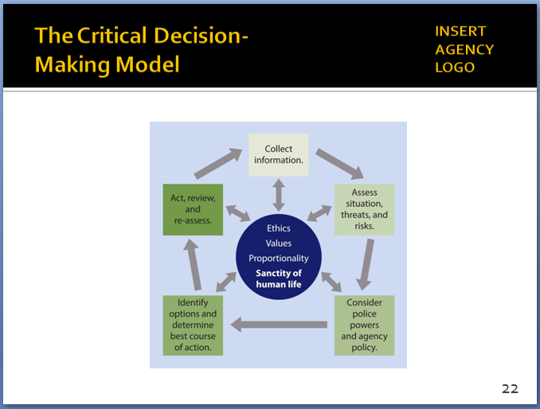

SLIDE #23
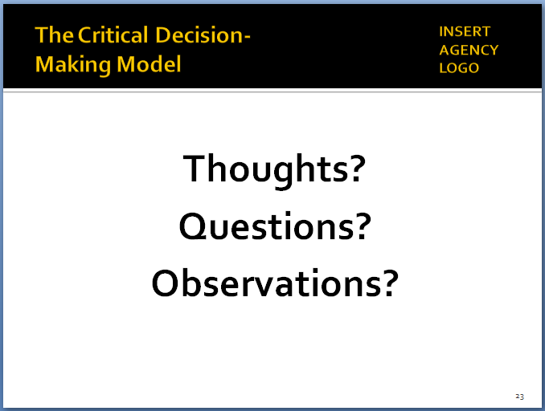

- Recap and Discussion
  - CDM not just another checklist for officers to fill out
    - It is thinking process – a process to help you make better decisions
    - A structure to help you articulate those decisions
  - CDM can be “spun” as quickly or as deliberately as appropriate for the situation
    - If an officer needs to act immediately, that’s OK
    - If there is time, the CDM helps you maximize it
    - Over time, the process become intuitive
  - Thoughts? Questions? Observations?

Appendix I: Background on PERF’s Critical Decision-Making Model
(also available at http://www.policeforum.org/assets/guidingprinciples1.pdf, pp. 79-87)

For decades, specialized police tactical units such as SWAT have employed critical thinking and decision-making processes to guide their unique, often dangerous work. Prior to taking action, these teams typically take the time to collect and analyze information, assess risks and threats, consider contingencies, and then act and review. Most experienced SWAT members would consider it reckless to approach an assignment without first taking these steps.

As PERF explored training and tactics on use of force, one question kept coming up: If this type of critical thinking process works for specialized tactical units, why can’t it be used by patrol officers as well? If patrol officers had a structured, easy-to-use decision-making process to follow, and could combine that with tactical concepts such as distance, cover, and time, they could more effectively and safely resolve many types of critical incidents.

Other Decision-Making Models

For several years, police personnel in England, Scotland, Northern Ireland, and Wales have utilized the National Decision Model (NDM), a five-stage process that revolves around the police code of ethics. In the UK, police officers use the NDM when responding to unplanned incidents and also when planning operations that are know ahead of time, such as the handling of a major sporting event. The National Decision Model is employed by individual officers and teams, and it applies to both operational and non-operational situations. In fact, some of the early applications of the NDM were in support of police budgeting and administrative decisions.

During the PERF-led field visit to Scotland in November 2015, officials from 23 U.S. police agencies learned more about the NDM and observed training scenarios in which the NDM was used. Overall, the U.S. delegation was impressed with the NDM’s depth and simplicity. To members of Police Scotland, the NDM has become second-nature. From recruits up to the Chief Constable, personnel understand the model and can readily explain its purpose and implementation in clear and straightforward terms. And police officers in the UK use the NDM in hundreds of incidents every day—both serious and minor—to support sound and accountable decision making.

PERF researchers also examined other decision-making models. One of them is the OODA Loop (Observe, Orient, Decide, Act), which was developed in the 1950s by a U.S. Air Force Colonel named John Boyd. Like the NDM and other models, it is a recurring cycle that users work through as new information is observed and circumstances change. Although it was initially applied to decision-making in military combat operations, the OODA Loop over the years has been used in business, legal, and other professions. Some police agencies have applied the OODA Loop as well.

Why Adopt the Critical Decision-Making Model?

PERF’s 30 Guiding Principles recommend that police agencies adopt a decision-making framework for use during critical incidents and other tactical situations, and then train officers in how to use that framework. This section of the report presents the Critical Decision-Making Model (CDM) as a preferred framework that agencies can adopt.

The CDM is based largely on the UK’s National Decision Model and concepts from other models. Like the NDM, the CDM is a logical, straightforward, and ethically based thought process that is intended to help U.S. police officers manage a range of incidents effectively and safely. And while the CDM can be employed in wide range of events, PERF believes it will be especially valuable in helping officers manage those critical incidents we are trying to impact the most—i.e., situations involving subjects who either are unarmed or have an edged weapon, rock, or similar weapon, as well as incidents involving persons who are experiencing a mental health crisis or who are behaving erratically because of a developmental disability, a mental condition such as autism, substance abuse, or other conditions.
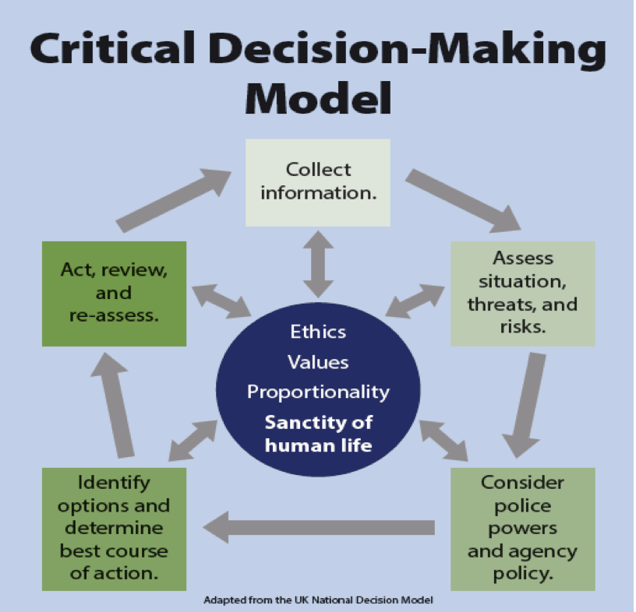
Elements of the CDM
The Critical Decision-Making Model is a five-step critical thinking process. All five steps are built around the core values of the department and the policing profession.

CDM Core

At the center of the CDM is an ethical core that provides grounding and guidance for the entire process. The four elements of the CDM core are:

• Police ethics
• Agency values
• Concept of proportionality (Guiding Principle #3)
• Sanctity of all human life (Guiding Principle #1).

Every step of the process is connected to this core, and the core informs and guides officers throughout the five steps. Everything an officer does within the CDM must support the ideals in the center, and no action can go against those standards.

Step 1: Collect Information

The logical first step in the process is for officers to gather information and intelligence, a process that begins as officers are heading toward the incident. During this step, officers ask themselves and others, including Dispatch personnel, a series of key questions.

It is important to remember that while the collection of information represents the beginning of the process, it is not a one-time activity in the CDM. Information gathering is ongoing, and new information is collected continuously to help inform the other steps in the process.

Officers should ask themselves …

- What do I know so far about this incident – the subject, victim, and location?
- What else do I need to know?
- What do my training and experience tell me about this type of incident?

Officers should query others (dispatchers, fellow officers, supervisors, computer networks) …

- What more can you tell me about this incident?

For example:
  - Circumstances that prompted the call
  - Individuals on the scene, the physical environment
  - Presence of weapons
  - Presence of bystanders, including children
  - Mental health/substance abuse issues
  - What more can you tell me about previous incidents involving this location or the person or persons who are involved?

Step 2: Assess Situation, Threat and Risks

This step typically begins as officers are responding to the incident and are evaluating what they are being told by dispatchers or others. That is the time when officers begin considering “what if?” scenarios in their minds. The assessment step shifts into high gear as officers arrive on scene and can visually begin to gauge threats and risks. During this step:

Officers should ask themselves …

- Do I need to take immediate action?
- What is the threat/risk, if any?
- What more information do I need?
- What could go wrong, and how serious would the harm be?
- Am I trained and equipped to handle this situation by myself?
- Does this situation require a supervisory response to provide additional planning and coordination?
- Do I need additional police resources (e.g., other less-lethal weaponry, specialized equipment, other units, officers specially trained in mental health issues)?
- Is this a situation for the police to handle alone, or should other agencies/resources be involved?

Officers should also request that others …

- Provide additional information, as needed.
- Respond to the scene, as needed.
- Provide the additional equipment or resources needed.

The first question in this step is noteworthy: “Do I need to take immediate action?” The CDM does not prevent or restrict officers from taking immediate action if that is what the circumstances dictate. In these situations, officers would “spin” through the rest of the model in a matter of seconds, determine the best course of action, and then act immediately.

For example, in active shooter situations, many American police agencies have policies directing the first officers at the scene to respond as quickly as possible to stop the threat. Some departments have policies that allow a single officer to move to stop the threat without waiting for any additional officers to arrive. Other departments have policies requiring officers to wait until a minimum number of officers can form a “contact team” to stop the shooter. Other agencies call for the creation of a contact team, often made up of four officers, but also specify that fewer officers may respond immediately if it is apparent that a full contact team cannot be assembled quickly. These are the types of factors that officers would quickly consider under the CDM in responding to this type of emergency.

However, if the answer to this question is, “No, I do not need to take immediate action,” then officers can go through the CDM at a more deliberate pace. The CDM can be “spun” as quickly or as deliberately as circumstance dictate, and officers can always take immediate action if that is appropriate.

Step 3: Consider Police Powers and Agency Policy

This step represents an important self-check of officers’ authority to take action. In addition to considering their legal authority to act, officers must think about what their agencies’ policies say about the situation.

For example, a police agency’s policy may place restrictions, beyond what is allowed by law, on shooting at vehicles, engaging in vehicle or foot pursuits, or using less-lethal options in certain situations. These internal policies must be considered at this stage, before specific options are identified and actions taken. During this step:

Officers should ask themselves …

- What legal powers do I have to take action?
- What agency policies control my response?
- Are there other issues I should think about? (e.g., jurisdictional or mutual aid considerations—Am I authorized to take action here?)

Step 4: Identify Options and Determine the Best Course of Action

Using the information and assessment from earlier steps, officers now begin to narrow their options and determine the best course of action. Again, part of this step is to determine if the officers have enough information and resources, and a compelling interest, to act right away. Or should they hold off, possibly to get even more information and resources? During this step:

Officers should ask themselves …

- What am I trying to achieve?
- What options are open to me?
- What contingencies must I consider if I choose a particular option?
- How might the subject respond if I choose a particular option?
- Is there a compelling reason to act now, or can I wait?
- Do I have the information and resources I need to act now?
Then, officers should select the best course of action, keeping in mind …

- The greatest likelihood of success and the least potential for harm.
- How proportional the response will be, given the risk/threats posed by the subject and the totality of the circumstances.
- The safety of the public, officer safety, and the sanctity of all life.

Step 5: Act, Review and Reassess

In this step, officers execute the plan, evaluate the impact, and determine what more, if anything, they need to do.

Officers should execute the plan, and then ask themselves …

- Did I achieve the desired outcome?
- Is there anything more I need to consider?
- What lessons did I learn?

If the incident is not resolved, then officers should begin the Critical Decision-Making Model again, starting with the collection of additional information and intelligence.

Benefits of the Critical Decision-Making Model

The thought processes embedded in the CDM are not very different from what many police officers already do on a daily basis. The CDM is certainly in line with how specialized tactical units are trained to approach their assignments. And it likely reflects the activities of many patrol officers, whether consciously or by instinct, when responding to calls for service or engaging in proactive policing.

What is new and different about the CDM is that it offers a structure for working through a series of steps that officers may already be following and questions they are probably asking already. This structure helps to ensure that each critical step is followed and that all key questions are asked along the way.

Useful in Everyday Situations and Complex, High-Risk Incidents

By practicing the CDM in everyday situations, officers become more fluent in asking questions and formulating effective plans for their responses to a variety of situations.

These skills are critically important when the officers are called on to respond to especially difficult, complex, or high-risk incidents. Officers who have used decision models speak of developing “muscle memory” in making critical decisions through everyday practice.

The CDM provides operational support for many of the key concepts articulated in the PERF’s 30 Guiding Principles—for example, using distance and cover to create time, applying de-escalation strategies, considering the proportionality of police actions, and handling individuals experiencing mental health crises. The CDM will help police officers put these concepts into action by providing them with a logical thought process for managing challenging situations.

The CDM offers an alternative to officers who in the past have been trained to “rush in and take control,” even when those responses are not appropriate or safe given the circumstances.

A Framework for Explaining Actions After the Fact

In addition, the CDM gives officers a framework for explaining the thought process behind their actions after the fact, such as when they testify in court or provide statements to investigators. The experience in the UK has demonstrated that the NDM can be quite valuable in helping officers describe and explain their actions, which lends credibility to their testimony. Officials report that officers routinely use the NDM as the outline for articulating their actions and decisions (“I first collected information by asking the following questions. Then I assessed the threat and risk by asking these questions….”).

The CDM should have similar benefits in the United States by providing officers with a detailed and logical mechanism for explaining their actions and decisions beyond the boilerplate language that is often found in police reports today.

For the CDM to be effective and beneficial, agencies must commit to thoroughly training their personnel on it. Scenario-based exercises should be coupled with the CDM. Officers who complete a particular scenario should then be asked to explain their actions in the context of the five-step CDM process and the core of the model.

Appendix II – Some Common Offender Risk Behaviors
(adapted from Police Scotland)

For the discussion of Step 2 of the Model (“Assess situation, threats and risks”), the following background information may be helpful.

  - Warning Signs
    - Generally subjects who are aroused to fight do not launch into an assault for fear of injury.
    - They initially begin by using attack gestures known as “ritualized combat.”
    - By learning to identify these signals, officers give themselves a significant advantage.
    - Warning Signs include:
      - Direct eye contact
      - Facial color darkens
      - Head back
      - Subject stands tall to maximize height
      - Kicking the ground
      - Large movements
      - Breathing rate accelerates
      - Stop/start behavior
  - Danger Signs
    - Danger signs are more than warning signs.
    - Subjects begin to lose control physically.
    - When this occurs their physical signals are significant and spontaneous.
    - It is critical that officers understand and recognize these signals as they are indicative of an imminent attack.
    - Neglecting or ignoring these signals will put the officer at a serious disadvantage.
    - Danger Signs include:
      - Fists clenching and unclenching
      - Facial color pales
      - Lips tighten over teeth
      - Head drops forward to protect throat
      - Eyebrows drop to protect eyes
      - Hands raised above waist
      - Shoulders tense
      - Stance changes from square to sideways
      - Subject breaks stare and looks for intended body targets
      - If the subject is out of breath, the final signal will be a lowering of their entire body before moving forward to attack
  - Impact Factors
    - Impact factors are those human and environmental differences which make each incident unique and every officer’s perceptions different.
    - These factors have a crucial bearing on making decisions and choice of tactics and may provide justification to use a specific level of force:
      - How should an officer approach the situation?
      - What should an officer say?
      - Does an officer need assistance?
- What personal protective equipment is the best option?
- Being aware of impact factors will not provide officers with answers, but will encourage them to ask the right questions
    - Impact Factors include:
      - Size, age, strength, gender
      - Drugs/alcohol
      - Ability
      - Numbers
      - Opportunity and intent to do you harm
      - Weapons
      - Skill levels
      - Injury/fitness
      - Exhaustion
      - Willingness to listen
      - Special knowledge
      - State of subject’s mental health
      - Subject’s physiology
      - Nature of crime
      - Clothing
      - Proximity of others
      - Danger to others
      - Police powers, skill and perception
      - Perception of the non verbal behavior of a subject
      - Perception of imminent danger
      - Perception of being in a position of disadvantage
      - Perception of the subject’s level of resistance
    - Environmental Impact Factors include:
      - Space
      - Proximity to furniture
      - Domestic situation (kitchen = access to weapons)
      - Escape routes
      - Weather conditions
      - Conditions underfoot
  - Profiled Offender Behavior
    - The term Profiled Offender Behavior encompasses the actions and behavior of the subject and comprises the warning and danger signs they exhibit, coupled with the impact factors present.
    - This profiled behavior will help determine the response.
    - Officers must react proportionally to the actions of the subject.
    - Profiled Offender Behavior is split into six categories which are as follows:
      - Compliance
        - Large percentages of subjects are reasonable and will comply with any lawful instruction given by the officer.
        - This compliance may be verbal or it may be active compliance such as stopping when told or showing the contents of their hands.
- Verbal Resistance and/or Gestures
        - Where a subject verbally refuses to comply with an officer’s request and/or exhibits body language which indicates non-compliance.
- Passive Resistance
        - This is non-active conduct with non-compliance (e.g., subject simulates a dead weight /sits or stands and will not move).
- Active Resistance
        - A form of conduct where the subject actively resists the officer but does not become assaultive (e.g., swallows drugs/runs away or struggles against officers).
- Assaultive Resistance
        - Physical conduct that results in a direct attack on an officer or person.
- Serious/Aggravated Resistance
        - The highest category of resistance displayed by a subject where there is a possibility of serious injury and/or death.
        - This could include the production of a weapon of any kind.
Dynamic Risk Assessment
In addition to any role-specific risk assessment, officers should conduct an assessment of any actions they are undertaking or being tasked to undertake. This is sometimes referred to as dynamic risk assessment. The eight guidelines for conducting dynamic risk assessments are:
      - Officers duty to protect/preserve human life; that includes their own
      - Officers should be aware of their physical limits — never take unnecessary risks
      - Officers should advise someone what they are doing (or going to do) and try to get support before they do it
      - Officers should seek information and advice — it will help them make a better decision
      - Officers apply correct procedures in every situation
      - Officers will record their decision-making process either at the scene or soon afterwards
      - Supervisors and managers are there to assist and offer guidance
Officers should establish an appropriate and prioritized working strategy.
It should be a proportional and focused policing response.
In assessing whether a response is proportional to the threat being faced, officers should consider the following:
- Am I using only the level of force necessary to mitigate the threat and safely achieve a lawful objective?
- Is there another, less injurious option available that will allow me to achieve the same objective as effectively and safely?
- Will my actions be viewed as appropriate—by my agency and by the general public—given the severity of the threat and totality of the circumstances?
For more information on the concept of proportionality, see PERF’s Guiding Principles on Use of Force, pp. 38-40 (available at http://www.policeforum.org/assets/guidingprinciples1.pdf).

